K-RIDE Marks Major Milestone in Railway Doubling Project with Launch of 61-Metre Girders at Chandapura

Bengaluru, 28 October 2026: K-RIDE has achieved a major engineering milestone with the launching of two 61-metre-long Open Web Girders (OWGs), each weighing approximately 245 metric tonnes, at Major Bridge No. 470 over National Highway-44 (NH-44) near Chandapura. The first girder was launched on 10th October 2026, followed by the successful launching of the second girder on 28th October 2026. This marks a significant milestone in the 48-km Baiyappanahalli–Hosur (BYPL–HSRA) Railway Doubling Project.
These are the longest girders launched by K-RIDE for a railway doubling project in Bengaluru and form part of the 48-km Baiyappanahalli–Hosur (BYPL–HSRA) Railway Doubling Project.
Technical Highlights
Each girder has a span of 61.00 metres and weighs approximately 245 metric tonnes. The structure is designed to accommodate both Up and Down railway lines on a common substructure, as per the approved design.
The launching operation employed a specialised winch-based pulling system and temporary staging arrangements using ISMB 600 steel sections, requiring precise structural alignment, stringent safety measures and coordinated execution to minimise disruption to NH-44 traffic. The General Arrangement Drawing (GAD), structural design drawings and Temporary Arrangement Drawing (TAD) were approved by Headquarters, Hubballi Division, South Western Railway (HQ/UBL/SWR).
Improving NH-44 Traffic Flow
The new long-span structure eliminates the need for an intermediate pier within the highway span, providing unobstructed passage beneath the railway bridge. Following completion of the associated railway works, demolition of the existing bridge and necessary highway improvements, the arrangement is expected to support the planned 12 lane highway configuration, subject to the approved design.
The project is expected to reduce congestion and travel delays, improve road safety and support future highway expansion in coordination with the National Highways Authority of India (NHAI). Railway doubling will also enhance rail capacity and operational flexibility for passenger and freight services along the Bengaluru–Hosur corridor.
Significant Benefits for the Public: The infrastructure intervention is expected to deliver substantial public benefits by addressing a major traffic constraint on NH-44. Once the associated works are completed, it will support smoother traffic movement, reduce congestion and journey-time delays, improve travel-time reliability and enhance road safety. The improved highway configuration will benefit daily commuters, public transport users, freight operators and industries by facilitating more efficient movement between Bengaluru and Hosur. The unobstructed highway span will also support the planned highway configuration while avoiding an intermediate pier within the carriageway. The BYPL–HSRA Railway Doubling Project will complement these road improvements by enhancing railway capacity, increasing operational flexibility and facilitating smoother movement of passenger and freight trains. Upon completion and commissioning, the combined road and rail infrastructure improvements are expected to strengthen regional connectivity, support industrial and commercial activity, and meet the growing mobility needs of the Bengaluru–Hosur corridor.
Shri Lakshman Singh, Managing Director, K-RIDE / Bi-RIDE, stated “The successful placement of both girders marks a significant milestone in the BYPL–HSRA Railway Doubling Project. The grade-separated crossing will enable road and rail traffic to move independently, minimising disruptions to highway traffic caused by railway operations. Once completed and commissioned, the facility will improve traffic flow and enhance the efficiency of transport operations at this crossing.
The associated railway and other works are targeted for completion by January 2027. This progress reflects our continued commitment to engineering excellence, quality infrastructure development and improved regional connectivity across Karnataka.
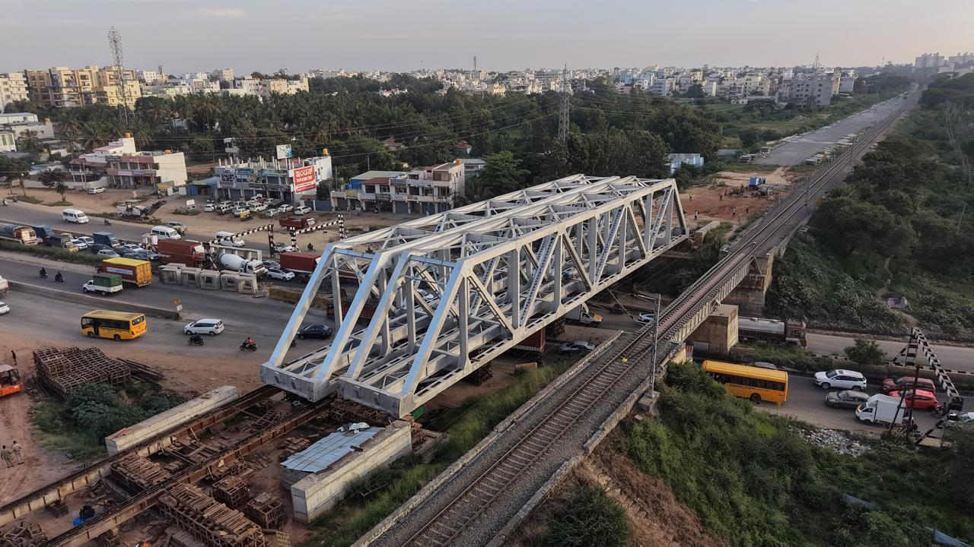

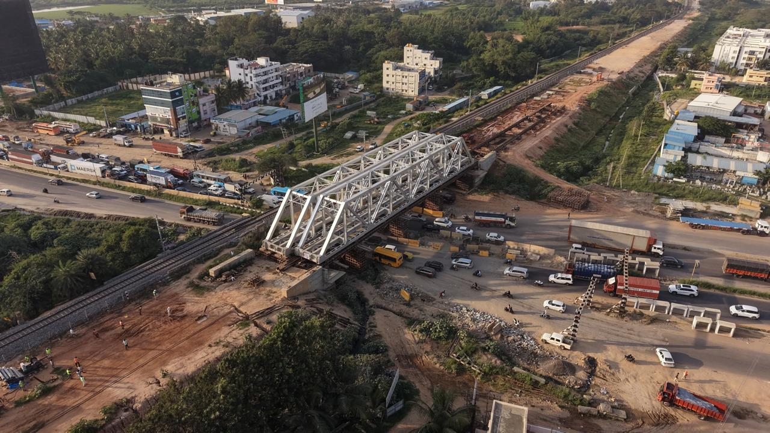

Managing Director
K-RIDE/Bi-RIDE
“Samparka Soudha”, 1st Floor, (Opp. Orion Mall),
Dr. Rajkumar Road, Rajajinagar 1st Block,
Bengaluru – 560 010

